
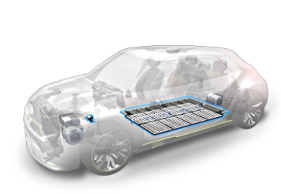

Project Purchasing Trainee/VIE (POWER Thermal Activity)

Jingzhou, Hubei Province – For onboarding as soon as March 2025

VALEO POWER Thermal Systems designs and manufactures systems, modules and components to optimize thermal management of vehicles and passenger comfort in the cabin. The POWER Division pursues three strategic objectives that address the new challenges facing the automotive industry:

- Reducing pollution emissions produced by vehicles powered by internal combustion engines.
- Optimizing battery range and lifespan in hybrid and electric vehicles.
- Protecting the health and well-being of passengers.

In China since 1994, Valeo has now more than 35 plants, 12 R&D Centers and 19 000 employees. Valeo Jingzhou’s plant is one the main manufacturers of Thermal devices, fully involved in the Electrical Car transition. It provides systems to the main Foreign and Chinese OEMs for local and export markets.

Mission

TRAINEE or VIE

Your mission will be focused on project purchasing KPI follow-up and analysis
- P1 project PPI, current and forecast with associated PAP
- Sourcing ratio vs Budget
- Weekly UIS follow-up and coordinate with P1 buyers/leaders
- Monitor SOCO events cleanliness in PUMA
- BL/LTA per segment analysis
- Set up BH(matching part)/CC(plastic part)/BD(stamping) data base for components and tooling cost model
- Potentially act as PTM for specific project

Successful candidate will have significant opportunities of development in Jingzhou’s site or in another site

Skills required

Education, Experience: Bachelor Degree, Master Degree in Logistics Management and Engineering with Major in Procurement and Supply Chain Management

Competences required:
Result and deadline orientation, “can do” attitude, adaptability, problem solving, resistance to pressure, ability to communicate efficiently in written and oral English. Excel proficiency.
Language: English speaking is mandatory, Mandarin is welcome

Contact
Send your application to chao.li@valeo.com and yan.tong@valeo.com Visit our site www.valeo.com

